CHRISTIAN UNION
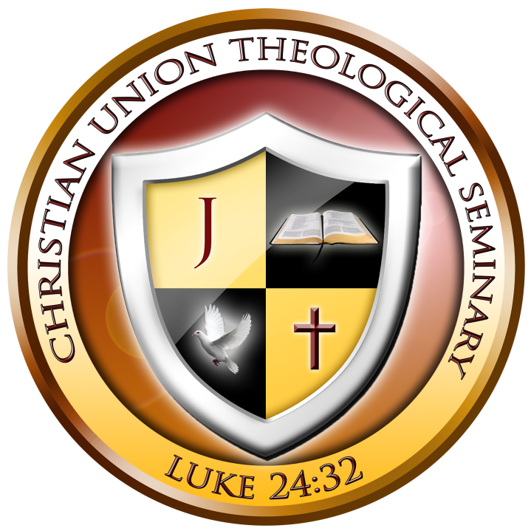
THEOLOGICAL SEMINARY

_____________________________________________________________________________________

Wednesday, May 25, 2022

Daly Morales
1604 Ludington Ave
Wesley Chapel, Florida 33543
Student ID# 33FL-MCC8387-2

SUBJECT: CERTIFICATION OF STUDIES

To Whom It May Concern:
This letter is to certify that since May 22, 2022 [Daly Morales] is enrolled as a full-time student pursuing a Master’s Degree in Christian Counseling, M.C.C., at the Christian Union Theological Seminary (CUTS). She is currently in good standing and is in the thesis stage of his studies.
This student is expected to complete the program and graduate in (May/2023) with the following degree (Master’s Degree in Christian Counseling).
For additional information, please contact CUTS’s Students and Scholars Office at telephone: (413) 883-4893 or fax: 1+ (877) 525-0420.

For His Glory,
Sara M. Simpson
Sara M. Simpson
Students and Scholars Office

303 Homestead Avenue | Holyoke, MA 01040-1380 | (413) 459-0590 | (800) 311-7063 | www.cutsedu.org

